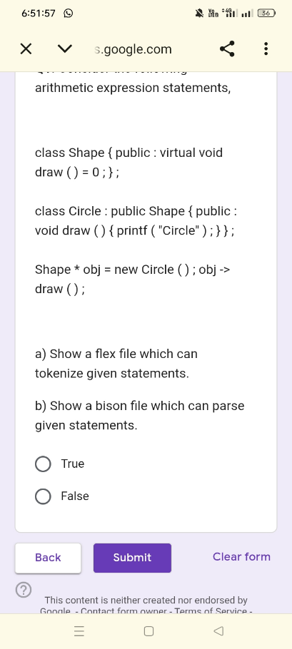

%{
#include "y.tab.h"
%}
%%
"class" { return CLASS; }
"public" { return PUBLIC; }
"virtual" { return VIRTUAL; }
"void" { return VOID; }
"new" { return NEW; }
"printf" { return PRINTF; }

[a-zA-Z_][a-zA-Z0-9_]* { return ID; }
[0-9]+ { return NUM; }
\"[^\"]*\" { return STRING_LITERAL; }
"->" { return ARROW; }
[ \t\n]+ { /* Ignore spaces, tabs, and newlines */ }
. { return yytext[0]; } /* Catch-all for single characters like { } ; ( ) = : * */
%%

int yywrap() {
return 1;
}

###bison file:
%{
#include <stdio.h>
#include <stdlib.h>

void yyerror(const char *s);
int yylex();
%}

%token CLASS PUBLIC VIRTUAL VOID NEW PRINTF ID NUM STRING_LITERAL ARROW

%%
/* Starting rule */
program:
statements
;

statements:
statement statements
| /* empty */
;

statement:
base_class_decl
| derived_class_decl
| object_instantiation
| method_call
;

/* Parses: class Shape { public : virtual void draw () = 0 ; } ; */
base_class_decl:
CLASS ID '{' PUBLIC ':' VIRTUAL VOID ID '(' ')' '=' NUM ';' '}' ';'
;

/* Parses: class Circle : public Shape { public : void draw () { printf ( "Circle" ) ; } } ; */
derived_class_decl:
CLASS ID ':' PUBLIC ID '{' PUBLIC ':' VOID ID '(' ')' '{' PRINTF '(' STRING_LITERAL ')' ';' '}' '}' ';'
;

/* Parses: Shape * obj = new Circle () ; */
object_instantiation:
ID '*' ID '=' NEW ID '(' ')' ';'
;

/* Parses: obj -> draw () ; */
method_call:
ID ARROW ID '(' ')' ';'
;

%%
void yyerror(const char *s) {
fprintf(stderr, "Syntax Error: %s\n", s);
}
int main() {
printf("Enter the C++ statements to parse:\n");
if (yyparse() == 0) {
printf("Statements parsed successfully!\n");
}
return 0;
}

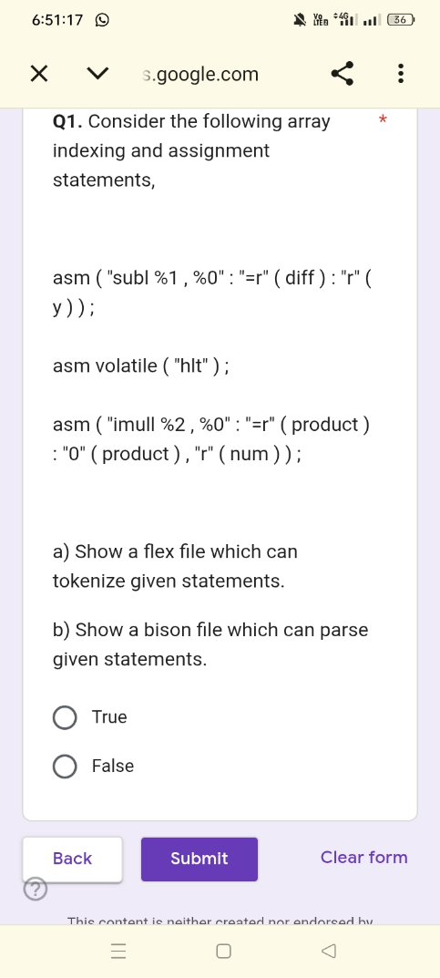

%{
#include "y.tab.h"
%}
%%
"asm" { return ASM; }
"volatile" { return VOLATILE; }
[a-zA-Z_][a-zA-Z0-9_]* { return ID; }
\"[^\"]*\" { return STRING_LITERAL; }

[ \t\n]+ { /* Ignore spaces, tabs, and newlines */ }
. { return yytext[0]; } /* Catch-all for single characters like ( ) : , ; */
%%
int yywrap() {
return 1;
}

####bison:
%{
#include <stdio.h>
#include <stdlib.h>

void yyerror(const char *s);
int yylex();
%}

%token ASM VOLATILE ID STRING_LITERAL

%%
/* Starting rule */
program:
statements
;

statements:
statement statements
| /* empty */
;

statement:
asm_basic
| asm_extended
;

/* Parses basic assembly: asm volatile ( "hlt" ) ; */
asm_basic:
ASM VOLATILE '(' STRING_LITERAL ')' ';'
;

/* Parses extended assembly: asm ( "..." : "=r" ( out ) : "r" ( in ) ) ; */
asm_extended:
ASM '(' STRING_LITERAL ':' output_operands ':' input_operands ')' ';'
;

/* Handles a single output operand like: "=r" ( diff ) */
output_operands:
STRING_LITERAL '(' ID ')'
| /* empty */
;

/* Handles one or more input operands separated by commas */
input_operands:
operand_list
| /* empty */
;

operand_list:
STRING_LITERAL '(' ID ')'
| operand_list ',' STRING_LITERAL '(' ID ')'
;

%%
void yyerror(const char *s) {
fprintf(stderr, "Syntax Error: %s\n", s);
}

int main() {
printf("Enter the asm statements to parse:\n");
if (yyparse() == 0) {
printf("Statements parsed successfully!\n");
}
return 0;
}

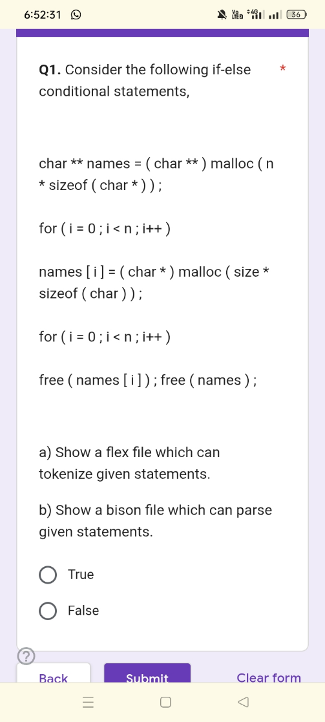

%{
#include "y.tab.h"
%}
%%
"char" { return CHAR; }
"malloc" { return MALLOC; }
"sizeof" { return SIZEOF; }
"for" { return FOR; }
"free" { return FREE; }

[a-zA-Z_][a-zA-Z0-9_]* { return ID; }
[0-9]+ { return NUM; }

"++" { return INC; }
"<" { return LESS_THAN; }
"*" { return '*'; }
"=" { return '='; }
"(" { return '('; }
")" { return ')'; }
"[" { return '['; }
"]" { return ']'; }
";" { return ';'; }
[ \t\n]+ { /* Ignore spaces, tabs, and newlines */ }
. { return yytext[0]; } /* Fallback for any other single character */
%%
int yywrap() {
return 1;
}

####bison----
%{
#include <stdio.h>
#include <stdlib.h>

void yyerror(const char *s);
int yylex();
%}

%token CHAR MALLOC SIZEOF FOR FREE ID NUM INC LESS_THAN

%%
/* Starting rule */
program:
statements
;

statements:
statement statements
| /* empty */
;

statement:
double_ptr_allocation
| array_element_allocation
| loop_construct
| free_array_element
| free_pointer
;

/* Parses: char ** names = ( char ** ) malloc ( n * sizeof ( char * ) ) ; */
double_ptr_allocation:
CHAR '*' '*' ID '=' '(' CHAR '*' '*' ')' MALLOC '(' ID '*' SIZEOF '(' CHAR '*' ')' ')' ';'
;

/* Parses: names [ i ] = ( char * ) malloc ( size * sizeof ( char ) ) ; */
array_element_allocation:
ID '[' ID ']' '=' '(' CHAR '*' ')' MALLOC '(' ID '*' SIZEOF '(' CHAR ')' ')' ';'
;

/* Parses the for loop and the single statement it executes */
/* Parses: for ( i = 0 ; i < n ; i++ ) */
loop_construct:
FOR '(' ID '=' NUM ';' ID LESS_THAN ID ';' ID INC ')' statement
;

/* Parses: free ( names [ i ] ) ; */
free_array_element:
FREE '(' ID '[' ID ']' ')' ';'
;

/* Parses: free ( names ) ; */
free_pointer:
FREE '(' ID ')' ';'
;
%%
void yyerror(const char *s) {
fprintf(stderr, "Syntax Error: %s\n", s);
}
int main() {
printf("Enter the C statements to parse:\n");
if (yyparse() == 0) {
printf("Statements parsed successfully!\n");
}
return 0;
}

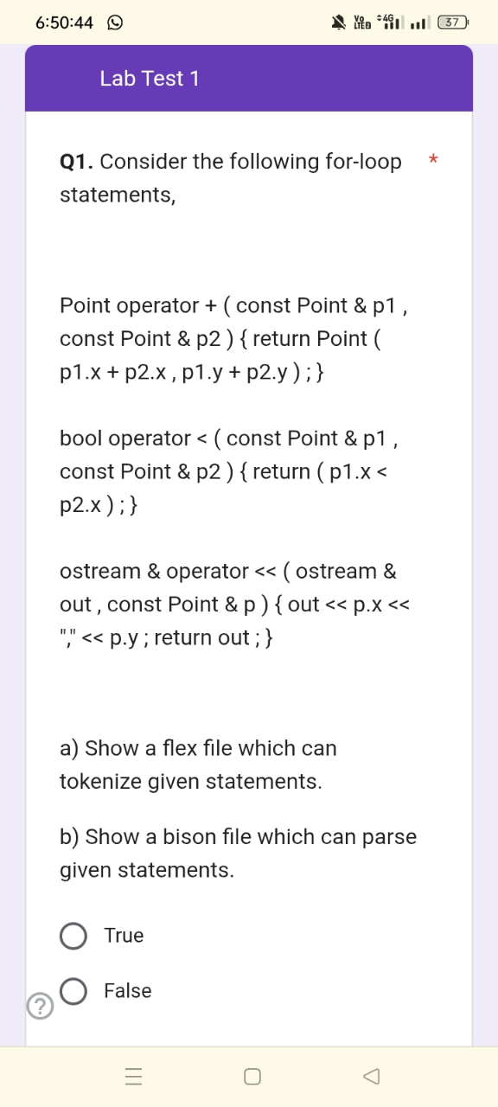
%{
#include "y.tab.h"
%}

%%
"Point" { return POINT; }
"operator" { return OPERATOR; }
"const" { return CONST; }
"bool" { return BOOL; }
"ostream" { return OSTREAM; }
"return" { return RETURN; }

[a-zA-Z_][a-zA-Z0-9_]* { return ID; }
\"[^\"]*\" { return STRING_LITERAL; }
"<<" { return LSHIFT; }
"+" { return '+'; }
"<" { return '<'; }
"(" { return '('; }
")" { return ')'; }
"{" { return '{'; }
"}" { return '}'; }
"&" { return '&'; }
"," { return ','; }
"." { return '.'; }
";" { return ';'; }
[ \t\n]+ { /* Ignore spaces, tabs, and newlines */ }
. { return yytext[0]; } /* Catch-all for unrecognized characters */
%%
int yywrap() {
return 1;
}

###bison----
%{
#include <stdio.h>
#include <stdlib.h>

void yyerror(const char *s);
int yylex();
%}

%token POINT OPERATOR CONST BOOL OSTREAM RETURN ID STRING_LITERAL LSHIFT

%%
/* Starting rule */
program:
statements
;

statements:
statement statements
| /* empty */
;

statement:
add_op_overload
| less_than_op_overload
| stream_op_overload
;

/* Parses: Point operator + ( const Point & p1 , const Point & p2 ) { return Point ( p1.x + p2.x , p1.y + p2.y ) ; } */
add_op_overload:
POINT OPERATOR '+' '(' CONST POINT '&' ID ',' CONST POINT '&' ID ')' '{' RETURN POINT '(' ID '.' ID '+' ID '.' ID ',' ID '.' ID '+' ID '.' ID ')' ';' '}'
;

/* Parses: bool operator < ( const Point & p1 , const Point & p2 ) { return ( p1.x < p2.x ) ; } */
less_than_op_overload:
BOOL OPERATOR '<' '(' CONST POINT '&' ID ',' CONST POINT '&' ID ')' '{' RETURN '(' ID '.' ID '<' ID '.' ID ')' ';' '}'
;

/* Parses: ostream & operator << ( ostream & out , const Point & p ) { out << p.x << " " << p.y ; return out ; } */
stream_op_overload:
OSTREAM '&' OPERATOR LSHIFT '(' OSTREAM '&' ID ',' CONST POINT '&' ID ')' '{' ID LSHIFT ID '.' ID LSHIFT STRING_LITERAL LSHIFT ID '.' ID ';' RETURN ID ';' '}'
;

%%

void yyerror(const char *s) {
fprintf(stderr, "Syntax Error: %s\n", s);
}

int main() {
printf("Enter the operator overloading statements to parse:\n");
if (yyparse() == 0) {
printf("Statements parsed successfully!\n");
}
return 0;
}

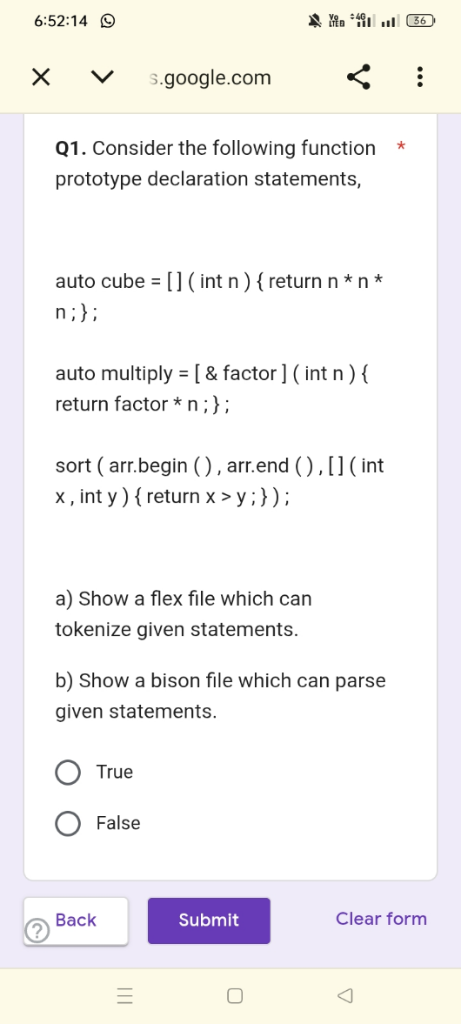

%{
#include "y.tab.h"
%}

%%
"auto" { return AUTO; }
"int" { return INT; }
"return" { return RETURN; }
"sort" { return SORT; }

[a-zA-Z_][a-zA-Z0-9_]* { return ID; }

"[" { return '['; }
"]" { return ']'; }
"(" { return '('; }
")" { return ')'; }
"{" { return '{'; }
"}" { return '}'; }
"=" { return '='; }
"*" { return '*'; }
"&" { return '&'; }
">" { return '>'; }
"," { return ','; }
"." { return '.'; }
";" { return ';'; }

[ \t\n]+ { /* Ignore spaces, tabs, and newlines */ }
. { return yytext[0]; } /* Catch-all for unrecognized characters */
%%

int yywrap() {
return 1;
}

###bison----
%{
#include <stdio.h>
#include <stdlib.h>

void yyerror(const char *s);
int yylex();
%}

%token AUTO INT RETURN SORT ID

%%
/* Starting rule */
program:
statements
;

statements:
statement statements
| /* empty */
;

statement:
lambda_basic
| lambda_with_capture
| sort_with_lambda
;

/* Parses: auto cube = [ ] ( int n ) { return n * n * n ; } ; */
lambda_basic:
AUTO ID '=' '[' ']' '(' INT ID ')' '{' RETURN ID '*' ID '*' ID ';' '}' ';'
;

/* Parses: auto multiply = [ & factor ] ( int n ) { return factor * n ; } ; */
lambda_with_capture:
AUTO ID '=' '[' '&' ID ']' '(' INT ID ')' '{' RETURN ID '*' ID ';' '}' ';'
;

/* Parses: sort ( arr.begin ( ) , arr.end ( ) , [ ] ( int x , int y ) { return x > y ; } ) ; */
sort_with_lambda:
SORT '(' ID '.' ID '(' ')' ',' ID '.' ID '(' ')' ',' '[' ']' '(' INT ID ',' INT ID ')' '{' RETURN ID '>' ID ';' '}' ')' ';'
;

%%

void yyerror(const char *s) {
fprintf(stderr, "Syntax Error: %s\n", s);
}

int main() {
printf("Enter the C++ lambda statements to parse:\n");
if (yyparse() == 0) {
printf("Statements parsed successfully!\n");
}
return 0;
}

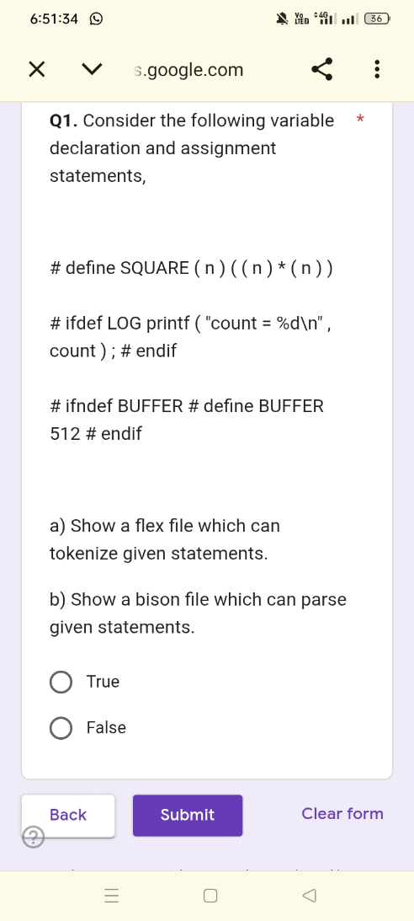

%{
#include "y.tab.h"
%}

%%
"#"[\ t]*"define" { return DEFINE; }
"#"[\ t]*"ifdef" { return IFDEF; }
"#"[\ t]*"ifndef" { return IFNDEF; }
"#"[\ t]*"endif" { return ENDIF; }
"printf" { return PRINTF; }

[a-zA-Z_][a-zA-Z0-9_]* { return ID; }
[0-9]+ { return NUM; }
\"[^\"]*\" { return STRING_LITERAL; }

"(" { return '('; }
")" { return ')'; }
"*" { return '*'; }
";" { return ';'; }
"," { return ','; }

[ \t\n]+ { /* Ignore spaces, tabs, and newlines */ }
. { return yytext[0]; } /* Catch-all */
%%

int yywrap() {
return 1;
}

###bison----
%{
#include <stdio.h>
#include <stdlib.h>

void yyerror(const char *s);
int yylex();
%}

%token DEFINE IFDEF IFNDEF ENDIF PRINTF ID NUM STRING_LITERAL

%%
/* Starting rule */
program:
statements
;

statements:
statement statements
| /* empty */
;

statement:
define_macro
| ifdef_block
| ifndef_block
;

/* Parses: # define SQUARE ( n ) ( ( n ) * ( n ) ) */
define_macro:
DEFINE ID '(' ID ')' '(' '(' ID ')' '*' '(' ID ')' ')'
;

/* Parses: # ifdef LOG printf ( "count = %d\n" , count ) ; # endif */
ifdef_block:
IFDEF ID PRINTF '(' STRING_LITERAL ',' ID ')' ';' ENDIF
;

/* Parses: # ifndef BUFFER # define BUFFER 512 # endif */
ifndef_block:
IFNDEF ID DEFINE ID NUM ENDIF
;

%%

void yyerror(const char *s) {
fprintf(stderr, "Syntax Error: %s\n", s);
}

int main() {
printf("Enter the preprocessor statements to parse:\n");
if (yyparse() == 0) {
printf("Statements parsed successfully!\n");
}
return 0;
}

